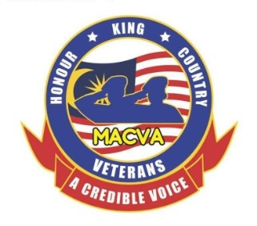
MALAYSIAN ARMED FORCES CHINESE VETERANS ASSOCIATION
32, Jalan Sri Ehsan 1
Taman Sri Ehsan
52100 Kuala Lumpur
Tel: +603 6274 3378 Fax: +603 6274 3379
website: www.macva.org.my

MACVA ASSOCIATE MEMBERSHIP (AM) APPLICATION FORM (Form MACVA/2)

- Name & Rank : Name: _______________________ Rank:______

- Service No. : _____________ NRIC No.: __________________

- Army (Corps) / RMN / RMAF/ TA / RMN / RMAF Reservist : ____________________

- Date of Enlistment (ORs) : __________________ ROD: ______________

- Date of Commission (OFFRs) : __________________ ROD: ________________

- House /Mobile phone number : House: ______________Mobile: ______________

- Email Address : __________________________________________

- Name of Spouse : __________________________________________

- Next of Kin (NOK) : ___________________________Tel:____________

- Home Address : __________________________________________

____________________________________________________Postcode: ________

I hereby declare that I am a Malaysian Armed Forces Veteran or retired Reservist and I have not been retired or discharged from service on grounds of misconduct.

Signature: Date:

Proposed by: Signature: Date:

Seconded by: Signature: Date:

Associate Membership Donation: Minimum RM200.00 (please attach banked in slip)

Account Name: Malaysian Armed Forces Chinese Veterans Association

Bank Name: Public Bank Account Number: 3200376816
____________________________________________________________________________

For Office use:

Approved by the Management Committee Meeting No. Date:

Please attach a passport size photo and donation banked in slip and email to Honorary Secretary howengkong@gmail.com or whatsapp to 012-201153 or post to MACVA office.

