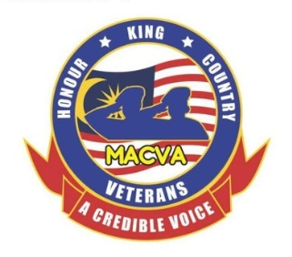
MALAYSIAN ARMED FORCES CHINESE VETERANS ASSOCIATION
32, Jalan Sri Ehsan 1
Taman Sri Ehsan
52100 Kuala Lumpur
Tel: +603 6274 3378 Fax: +603 6274 3379
website: www.macva.org.my

LIFE MEMBERSHIP (LM) APPLICATION FORM (Form MACVA/1)

- Rank & Name : _____________________________________________

- Service & NRIC Number : _____________ NRIC No: ______________________

- Place of Birth : _____________________________________________

- Army (Corps)/RMN/RMAF : _____________________________________________

- Date of Enlistment : _____________________________________________

- Date of Commission : _____________________________________________

- ROD (Last day of service) : _____________________________________________

- Telephone Numbers : House:_______________ Mobile:_________________

- Email Address : _____________________________________________

- Name of Spouse : _____________________________________________

- Next of Kin (NOK) : __________________________ Tel:_______________
- Home Address : _____________________________________________

_________________________________________________Postcode:______________

I hereby solemnly declare that I am a Malaysian Chinese Veteran and had served the Malaysian Armed Forces full time and I have not been retired or discharged from service on grounds of misconduct.

Signature: __________________________ Date: ______________________

Proposed by (Name): _____________________ Signature: __________ Date: _________

Seconded by (Name): _____________________ Signature: __________ Date: _________

Life Membership Fee: RM100.00 (Please attach bank slip) Donation (voluntary): RM ____

Account: Maybank - A/C No: 5144 8653 0465
Account Name: Malaysian Armed Forces Chinese Veterans Association

Please send your application to Honorary Secretary Tony Ho Weng Kong or
by email to howengkong@gmail.com or by Whatsapp to +6012 2001153

Please attach a passport size photo

Note: The NOK column must be filled for emergency (son/daughter/relative/close friend)

